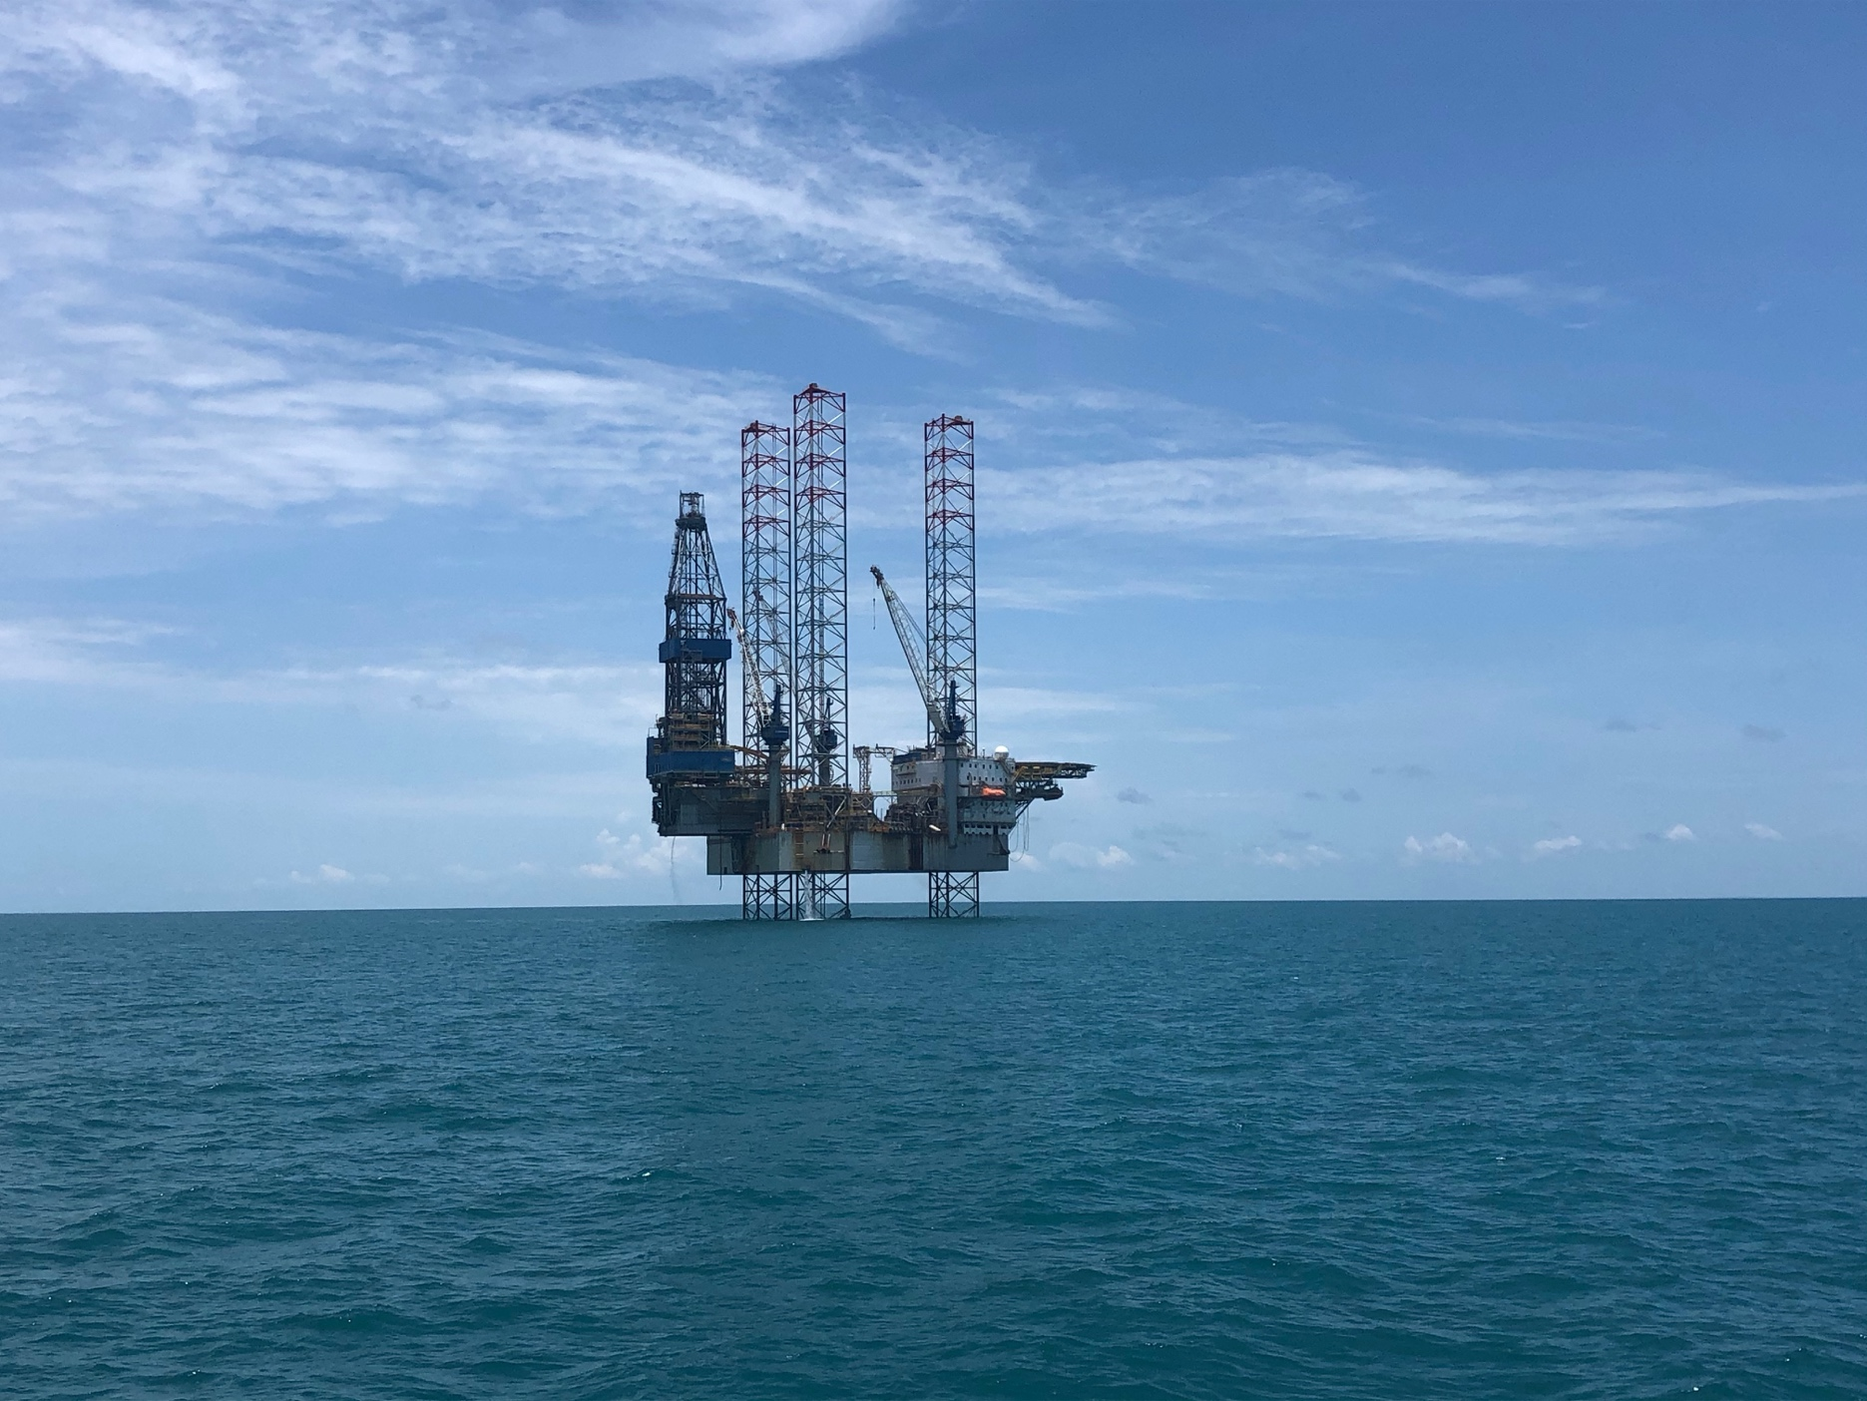

ENVIRONMENT PLAN
Beehive-1 Exploration Drilling: Public Comment Report

14 July 2022
Rev 0

- Introduction
In accordance with Regulation 9AB of the OPGGS(E), the Beehive-1 Drilling environment Plan (EP) was published on NOPSEMA’s website, along with an invitation for public comment on the plan, for 30 days from the 9th of May 2022; closing at midnight on the 8th of June 2022.
- Titleholder Contact Details
The nominated liaison person for this EP is:
Jonathan Chung
Director, Business Development International
1111 Bagby Street, Sky Lobby 2, Houston, Texas 77007 USA
+1 713-651-7000
australia@eogresources.com
- Public Comments
The comments and EOG’s responses are provided in Table 1.

Table 1 Summary of Comments and EOG’s Responses
# | Comments received (in general terms) | Titleholder response
1 | Matter: Unacceptable impacts to the environment
1a | Marine, nearshore and onshore ecosystems are at risk  Claim that marine, nearshore and onshore ecosystems are at risk, particularly the following key environmental receptors:  - The Joseph Bonaparte Gulf Australian Marine Park (AMP);  - The North Kimberley Marine Park;  - The Ord River Floodplain Ramsar site;  - King Shoals Sanctuary Zone; and  - Cape Domett Special Purpose Zone.  Provided information on the values of these receptors including cultural values of sea country interconnected with biodiversity values of the North Kimberley Marine, and ecologically significant offshore, nearshore and onshore ecological communities, coral reefs, seagrass communities, mangroves, migratory birds, sea turtles, dugongs, sawfish, Australian snubfin dolphins and finfish communities. Noted that the Conservation and Parks Commission (2016) recognises oil and gas developments in the neighbouring Commonwealth waters as a threat to water and sediment quality in the North Kimberley Marine Park.  Claim that modelling shows that areas close to the activity area are at high risk of exposure and likely impact from an oil spill. Claim that the proposal has the potential to produce direct and indirect impacts to ecologically significant offshore, nearshore and onshore ecological communities, including impacts to coral reefs, seagrass communities, mangroves, migratory birds, sea turtles, dugongs, sawfish, Australian snubfin dolphins, diverse finfish communities, which are all reliant on healthy marine ecosystem.  Requested further information on the potential impacts to the above receptors and on the measures to minimise the risks to significant environmental receptors. | EOG reviewed the information provided by the commenter and Appendix 5 of the EP (Description of the Existing Environment). The following management plans were also reviewed:  - Australian Marine Park North Marine Parks Network Management Plan 2018 (Director of National Parks, 2018) (includes the Joseph Bonaparte Gulf AMP).  - Ord River and Parry Lagoons nature reserves management plan 77 2012 (Department of Environment and Conservation 2012) (includes the Ord River Floodplain Ramsar Site).  - North Kimberley Marine Park Joint Management Plan 2016 Uunguu, Balanggaarra, Miriuwung Gajerrong, and Wilinggin management areas management plan 89 (WA Department of Parks and Wildlife, 2016) (includes the King Shoals Sanctuary Zone and the Cape Domett Special Purpose Zone).  These management plans were referenced in Appendix 5 of the EP in sections 5.4.1, 5.4.4 and 5.4.9, respectively. The information on the North Kimberley Marine Park in Section 5.4.9 of Appendix 5 of the EP was updated to include descriptions of the King Shoals Sanctuary Zone and the Cape Domett Special Purpose Zone. No further changes were made to Appendix 5 as a review found that the identified ecological and cultural receptors within the spill EMBA had been adequately described.  The impacts and risks which may influence water and sediment quality in the North Kimberley Marine Park were reviewed (Chapters 7 and 8 of the EP). The only risks which could have an impact were for oil spills or spill response activities.  A new appendix was added to the EP (Appendix 7: Assessment of the risk of a LoWC on the management actions of protected areas) providing further detail on the key environmental receptors’ probability of exposure to an oil spill (using the stochastic modelling results). Appendix 7 also includes an assessment of EOG’s compliance with these management plans, and provides information on the actions that would be taken in the event of a spill.  Section 8.7 of the EP (RISK 7 – Loss of Well Containment and Major Oil Spill) was reviewed and revised to provide a clearer explanation of how the modelling is interpreted for the risk assessment. The risk assessment method is described in detail in Chapter 6 of the EP.  Section 8.7.1 outlines how the risk assessment is based on the consequences arising from a worst-case spill scenario, where oil freely flows for 77 days (i.e. until a relief well is drilled and the well killed). This scenario assumes multiple failures of control systems (as described in Sections 8.7.6) and that no spill response activities are implemented (as described in Section 8.8 of the EP and in detail in the OPEP).  Section 8.7.4 explains that the modelling (Appendix 6) for these worst-case scenarios is based on stochastic modelling whereby 100 individual spill scenarios (for each season) are combined to provide an overall area, known as the environment that may be affected (EMBA), where impacts may potentially occur in the event of any particular oil spill. It should be noted that no individual spill would cover the entire EMBA.  Deterministic modelling was used to track individual scenarios to give an indication of what may actually occur in the event of an oil spill. Figure 8.11 of the EP shows the individual scenario which resulted in the largest volume of oil ashore. For oil spill planning purposes (see the OPEP and OSMIP), the cumulative, stochastic area (EMBA) is used to determine the overall area for which preparations are required, while the deterministic trajectories are used to determine worst-case resourcing requirements.  Section 8.7.1 presents data showing that the frequency of a blowout was 3.1 x 10⁻⁴ (0.00031, or 0.031%) per exploration well drilled between 1980 and 2004 (OGP, 2010 in DNV, 2011). The inherent likelihood of a blowout occurring was assessed as ‘rare’ in Section 8.7.6. The likelihood was further reduced to ‘remote’ with additional controls and mitigation measures for well control incorporated into the activity, including learnings from the Macondo and Montara blowouts. EOG considers the rankings are appropriate in the context of blowout frequency and controls that will be applied to this activity.  The evaluation of environmental risks (Section 8.7.5 of the EP) was reviewed. The existing evaluations were found to adequately identify and assess potential impacts on significant environmental receptors. Table 8.30 (Sensitivity and consequence evaluation of hydrocarbon exposure to intertidal communities – tidal flats) was added to the EP to provide a specific assessment of tidal flats. A note was added to Table 8.37 linking to Appendix 7 (see below). Minor editorial changes were made throughout Section 8.7.5.  The risk assessment (Section 8.7.6) was reviewed. The additional environmental risk evaluation (tidal flats) was included. The existing controls were found to be appropriate for the nature and scale of the activity. The environmental performance outcomes (EPOs), environmental performance standards (EPS’) and their measurement criteria were reviewed. One change was made to the EPS (and measurement criteria) regarding testing records for the blow-out preventer (RSK-07:EPS-03). No additional controls were considered to be practicable. With the proposed controls implemented, the risk was found to be reduced to as low as reasonably practicable (ALARP).  In considering whether the risk is acceptable EOG considered a number of factors, including the concerns raised by this commenter. With the additional responses detailed in the Oil Pollution Emergency Plan (OPEP) and the Operational and Scientific Monitoring Implementation Plan (OSMIP), EOG considers the risk of a spill resulting from a LoWC to be acceptable because:  - The residual risk ratings are as low as can be achieved;  - The activity will be conducted in accordance with the company’s Safety and Environmental Policy which will ensure EPOs and EPS’ are achieved;  - An Implementation Strategy (described in Chapter 9) is in place to ensure the EPOs and EPS’ are achieved.  - Input from engagement with relevant persons has been considered and incorporated into the risk assessment;  - Relevant legislation and industry best practice has been identified and will be complied with;  - In the unlikely event of a spill, no long-term or significant impacts on MNES are predicted;  - In the unlikely event of a spill, the spill can be managed in a manner that is not inconsistent with:  - the aims of recovery plans/conservation plans/advice that are in force for EPBC Act-listed threatened and migratory species;  - the aims of relevant protected area management plans; and  - ESD principles.  The risk from spill response activities (Section 8.8 of the EP) was reviewed. Potential environmental impacts are identified and assessed. The controls were found to reduce the risk to ALARP and appropriate for the nature and scale of the activity. The risk was considered acceptable. No changes were made.
1b | Greenhouse gas emissions impacts  Objection was made that the full extent of environmental risks from the activity have not been assessed because scope 3 greenhouse gas emissions (GHGe) are not included.  Requested further information on EOG’s management GHGe, the cumulative impacts of GHGe in the region, and the measures EOG will apply to reduce or offset any residual climate impacts from its GHGe. | Scope 3 emissions are not relevant for the assessment of the activity as it is an exploration well that will not be producing hydrocarbons for combustible use by EOG or any third parties. Further, the exploration permit EOG is operating under does not allow for the commercial extraction of resources. Therefore, only Scope 1 and 2 emissions are associated with the activity. Drilling is necessary to determine whether there are recoverable hydrocarbons in the part of the reservoir to be drilled and any future possibility of production.  Section 7.4 (IMPACT 4 – Routine Emissions – Atmospheric) was reviewed. Realistic estimates of carbon dioxide equivalent (CO₂-e) emissions are provided. Potential environmental impacts are identified and assessed. The controls were found to reduce the risk to ALARP and appropriate for the nature and scale of the activity. The risk was considered acceptable. No changes were made.
2 | Matter: Inadequate consultation with key stakeholder groups
2a | Inappropriate application of the IAP2 consultation  Claim made that EOG inappropriately applied the IAP2 consultation criteria by removing some key components of the IAP2, thus reducing its responsibilities to meaningfully consult with stakeholders. Commenter cited the IAP2 core values and claimed that EOG had misapplied these.  Requested further information on the application of the IAP2 criteria and values in the stakeholder consultation approach.  Claim that consultation with a much wider group of ‘relevant’ persons must first be initiated under Regulation 11A (1)(d) of the Petroleum and Greenhouse Gas Storage (Environment) Regulations 2009 (OPGGS(E)). | Section 4.4 (Engagement Approach) of the EP states that: “Consultation has been broadly undertaken in line with the International Association for Public Participation (IAP2) spectrum” (emphasis added). The IAP2 spectrum’s key elements are underpinned by the IAP2 core values. EOG did not represent it had adopted the IAP2 guidance in full.  EOG reviewed Chapter 4 (Stakeholder Consultation) of the EP and believes the approach described is consistent with the IAP2 core values. The engagement approach (Section 4.4) and the engagement methodology (Section 4.5) describe how consultation has occurred and Table 4.2 shows that relevant persons have been identified and appropriately consulted.  The EP was published on NOPSEMA’s website, along with an invitation for public comment, for 30 days from 9 May 2022 to 8 June 2022. EOG also placed advertisements with the NT News, The Australian and The West Australian newspapers on 12 May 2022, advising of the EP’s publication and inviting public comments. One commenter responded.  EOG initially identified 40 ‘relevant persons’ in accordance with the requirements of Regulation 11A (1)(d) and published NOPSEMA guidance (see Table 4.1 of the EP). EOG continues to consult with these stakeholders and recognises that it is possible for additional relevant persons to be identified as the project continues, such as the one commenter from the public comment period.  A number of changes were made to Chapter 4. Section 4.2 (Regulatory Requirements and Guidelines) upon review was expanded to include more detail on the regulatory requirements and guidance documents incorporated into EOG’s stakeholder consultation. Section 4.3 (Relevant Persons and Other Stakeholders Identification) was revised to clarify arrangements used to identify relevant persons and other stakeholders. Table 4.1 was updated with new stakeholders. Section 4.5 (Engagement Methodology) and Section 4.6 (Summary of Consultation with Relevant Persons) were updated with details of further consultation since the public exhibition of the EP. Table 4.2 was updated with summaries of consultation undertaken since the public exhibition of the EP. Section 4.7 (Public Exhibition of this EP) was updated with a brief summary of this commenter’s claims and objections, EOG’s response, and a reference to this titleholder response document.  Section 4.9 (Assessment of Objections and Claims) was revised to clarify the process used for assessing stakeholder’s objections and claims.  Appendix 3 (Stakeholder Communications) was updated with full transcripts of all consultation undertaken since the public exhibition of the EP. This has been provided in a confidential submission to NOPSEMA, including the response to any objections or claims provided by relevant persons.  EOG believes that it has appropriately identified and consulted with relevant persons, and that there has been ample opportunity for other stakeholders to identify themselves during the public exhibition of the EP.
2b | Relevant person under Regulation 11A  Commenter asserted that they were a relevant person under Regulation 11A of the OPGGS(E). | EOG acknowledges that the commenter has self-identified as a relevant person for the purposes of Regulation 11A of the OPGGS(E). EOG will further engage and consult with the commenter on that basis.

Previous Appendix 7 (Spill Response Strategic Net Environmental Benefit Analysis and ALARP Demonstration) becomes Appendix 8.
EOG commissioned RPS to prepare a revision of the oil spill modelling report to examine the potential benefit of applying surface dispersant as a mitigation measure (Appendix 6 of the EP).
Subsequent table numbers changed.

